**MINI PROJECT (OOPM)** OUTPUT

**# Face Attendance System :**

 

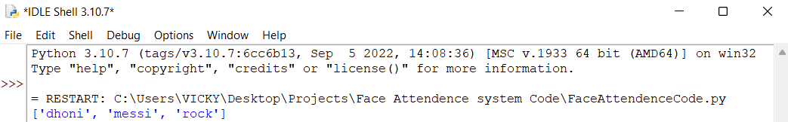

Absent students on 1st detection

** **

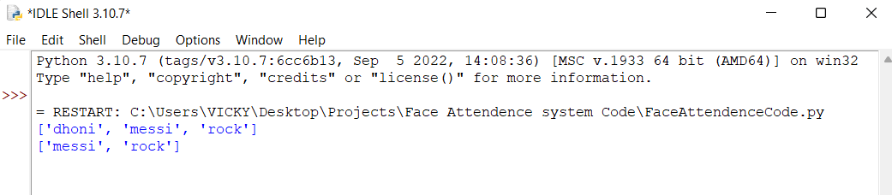

Absent students on 2nd detection

**Attendance exel file (.csv)**

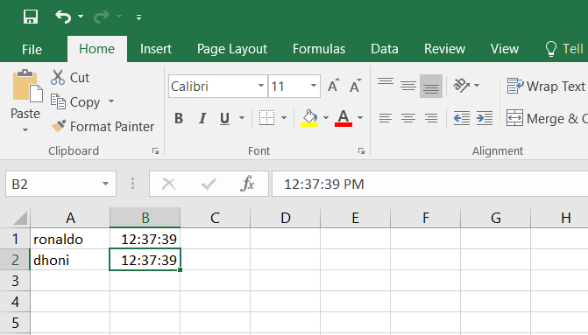

Output of Present students Attendance time